**Team D Task 10 (Due Nov 21)**

Manoj Kumar Chowdary Thammineni (6567916)

Deepak Chandrashekar (6614493)

Arundeep Malapati (6568025)

**PROJECT REPORT**

# **Introduction**

“Our bodies are our gardens – our wills are our gardeners.” ~William Shakespeare

“Take care of your body. It’s the only place you have to live.” ~Jim Rohn

Health plays a vital role in people’s life; hence health must be constantly monitored. There are various ways to monitor the health status like visiting to the doctor, taking vital signs and validating that they are in normal range, etc. The technology in today’s world had made significant improvements over the years. Even the mobile technology has made a significant improvement in the growing world. There are various mobile applications being developed and used. One of the targeted mobile applications is that which can help to monitor the health status by providing various features to keep record of the vital signs, treatment history, etc. It also reduces the paperwork and helps illiterates even the literates to make use of this application to monitor their health.

# **Motivation**

Everyone has to maintain the health records in their lifetime; otherwise they may have to risk their life with chronically ill and unable to get treatment correctly. Classical way of maintaining the health documents and records is through maintaining the papers in a file or folder. It becomes hard to maintain and handle these documents all the time. The Illiterate people are not aware of keeping track the health documents. Some people often misplace or lose important health documents like vital sign readings, previous treatments, doctor suggestions, etc.

It is more interesting because everyone may face such problems in maintaining health records. The problem occurs:

* When people want to compare and analyze the vital sign readings considering their health background.
* When people need to take medication or record vital signs readings at regular interval of time.

My PHR application is developed to address such issues. My PHR application can be used to avoid the paper work, to maintain records in an easy manner, to provide graphical representation where in which user can compare vital signs easily and analyzing such information become easy and they can efficiently monitor their health status.

Other Ways of addressing such issues are: People can use applications like excel sheet to record the values in an efficient and effective manner, they can use To-Do lists for reminders, alarms to remind them, and use word documents to keep track of treatment history.

# **Design of My PHR**

# This application is a knowledge based system. It contains Facts and Rules (i.e., if-then-else).

# **Severity of the V-sign values:**

The facts about the normal range of V-sign values are stored.

The rules are as below –

* If the user provided V-sign value is within the normal range as mentioned in the fact, then the severity level is considered as normal.
* If the V-sign is greater than the normal range, then the severity level is considered as high.
* If the V-sign is lesser than the normal range, then the severity level is considered as low.

**Valid range of the V-sign values:**

The facts about the valid range of V-sign values are stored.

The rules are as below –

* If the user provided V-sign value is within the valid range as mentioned in the fact, then the user provided value is accepted.
* If the V-sign is lesser than the valid range, then user is alerted.
* If the V-sign is greater than the valid range, then user is alerted.

Once the user saves the V-signs reading, the user is provided with an option to remind about the next readings of the V-signs. This option is useful for the users who often forget the things and needs reminders.  This option should be non-obtrusive to the user. To make it unobtrusive a checkbox is provided in the UI, so that only if the user wants to keep a reminder then the user can select the checkbox, otherwise do nothing.

The prototype of the UI looks as below:

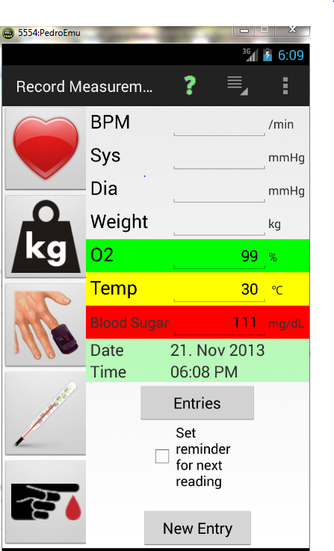

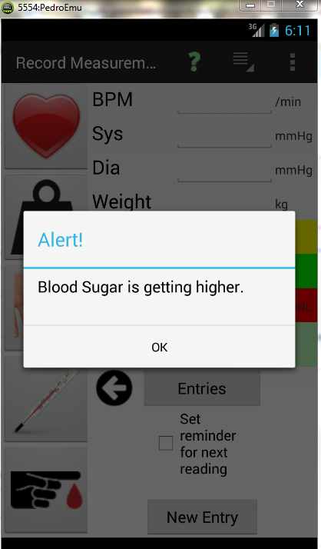

The facts are stored in the application in a XML file.

**For example**, for normal body temperature it should be in the range of 97 – 100 F.

This information/fact is saved as below:

  <?xml version="1.0"?>

  <v-sign id=”temperature”>

     <normal-range>

         <minimum> 97 </minimum>

         <maximum> 100 </maximum>

         <unit-of-measurement> Fahrenheit </unit-of-measurement>

     <normal-range>

  </v-sign>

# **Project Details**

This application will help the user in organizing the vital sign readings, treatment history in an efficient and effective manner. Graphical user interface helps the illiterate people including literate people in much better way to compare and analyze the data.

The UI adaptations are as follows:

* When user enters the values for the vital sign, the UI should ask user whether he need a reminder for next intake of vital sign.
* When the vital sign values are above or below the normal values it should indicate him the severity level.

The Properties and are as follows:

* + Body Temperature {low, normal, high}
  + Body Weight {previous weight, current weight}
  + Oxygen Level {low, normal, high}
  + Blood Pressure {low, normal, high}
  + Blood Sugar {low, normal, high}
  + Reminder Date & Time {present date, reminder date, present time, reminder time}

The rules for relevant properties are as follows:

* For normal body temperature it should be between 97 – 100 F
* Present weight > Previous weight ( weight gain )
* Present weight < Previous weight ( weight lost )
* Oxygen Levels (95-100%)
* The normal blood pressure should be in the range of 60-79 for diastolic and 90-119 for systolic.
* The normal sugar level is 70 to 100 mg/dl

The user context of use is being collected for this application is the vital sign values. This information is collected by using the instruments which are used to measure the vital signs.

**Challenges:**

* For sugar level vital sign the readings are to be taken at fasting and after fasting.
* The vital sign blood pressure severity depends on the age and gender of user
* The vital sign weight severity depends on the height and age of the user
* We don’t have any Android device and new to Android interface
* Complexity in understanding the code
* Emulator is slow to work

**Limitations:**

* Artificiality, User is not exposed to natural settings as it is a controlled setting experiment.
* User behavior in laboratory might not be same as in natural environments..
* Experiment is conducted on specified age group users.
* No scope for technology evaluation.
* Even though the experiments are conducted in controlled environments, it is not possible to control all the variables.

The project requirements are as follows:

* The application should be intelligent enough to alert the user if the entered values for the Vital Signs are out of range values.
* Based on the values entered by the user to the V-sign, there should be an automatic assessment on the severity level of the V-sign.
* Older people may require remainders, since they often forget things. So to notify them and alert the user, the application should have an intelligence to remind the user at specified time provided by the user.

The UI adaptations are as follows:

* When user enters the values for the vital sign, the UI check if the entered value is out of range values. If it is out of range the IUI alerts the user.
* The UI is provided with an option to alert the user as whether the user needs a reminder for next intake of vital sign. This option is unobtrusive, since only the interested users click on the checkbox to enable this reminder.
* After the vital sign are entered by the user, the values are validated and the severity level is indicated to the user like low, normal and high.

# **Evaluations**

We evaluated the usability of the MyPHR project involving the user under controlled settings to measure and observe users behaviour. Our aim was to test the usability of our project for the intended user population (i.e. older and middle aged people) to achieve the task for which our project is designed.

We performed this usability test on certain number (say 3-5) of users in controlled settings. We recorded the user readings and their performance while doing particular tasks by collecting the error count and time taken. User activities are observed and noted. User satisfaction is evaluated using questionnaires and interviews.

Usability testing focus on how well users perform tasks with the product. We have to focus on time taken by the user, number of errors, type of errors, user satisfaction. We need to find whether our project MyPHR is efficient, effective, safe and easy to learn.

Testing Conditions:

* Selecting different participants who are older/middle aged.
* Typically 3-5 participants.
* Test condition should be same for every participant.
* Test is conducted in a closed room like laboratory.
* The task should not be more than half an hour.
* Participants should be explained about the consent form and issues.

Testing Observations:

* Number of errors made by users for a task is to be noted.
* Time to complete the assigned task.
* Type of errors made by users.
* Common errors made by users.
* Number of users successfully completing the tasks.

# Usability is evaluated by selecting 3 participants of middle age. The participants are assigned with tasks which are held in controlled settings to test the MyPHR application. The user actions are observed and noted. Our aim is to test the specified age group (35 and above) users. So we planned accordingly to collect information. Collected information is given in the following table.

|  |  |  |  |  |
| --- | --- | --- | --- | --- |
| **User** | **No: of Errors** | **Error Description** | **Task Status** | **Time Taken** |
| **User 1** | 3 | Type Mistake, unable to plot selected values on graph. | Successfully completed | 27 min |
| **User 2** | 1 | Unable to plot graph for selected dates. | Successfully completed | 24 min |
| **User 3** | 1 | Enter details for treatment history. | Successfully completed | 19 min |

We evaluated tasks like reminder setting, providing out of range values and conveying the information about the severity level base on the V-signs provided by the user and to check if the users are interested or not interested in such severity level information.

The user context of use may vary according to the user intention, for example if we consider the blood sugar level vital sign then these values should be collected at fasting time and after having food. So the normal values for sugar level are different at different context so we need to keep in mind, if we consider sugar level vital sign.

**Interview:**

* What do you feel about this application?

**User1:** It is good, Useful health application.

**User2:** Good, but I have an Iphone in which your app is not supported.

**User3:** I don’t think it’s a good idea because I don’t like to monitor vital signs.

* Is it helpful to monitor your health?

**User1:** Yes, It is helpful

**User2:** Helpful

**User3:** May be helpful for people who are sick.

* What do you think of being notified when values are out of range?

**User1:** Purposefully no user gives infinite values, if they try to give such values it would be great if it notifies.

**User2:** Out of range values is like intentionally testing the app by proving abnormal values to the vital signs. If it notifies then it is tested according to that feature.

**User3:** It may happen unintentionally, so help user if it happens.

* Do you like to set reminder for alerting to take readings?

**User1:** No, I am not, but this is helpful to people who often forget.

**User2:** I like this, no need to remember timings to record my sugar levels.

**User3:** Yes, I like this because it reminds me when I may forget to record vital signs due to my daily schedule.

* Which vital signs would you like to monitor most?

**User1:** I like to monitor blood pressure and sugar levels.

**User2:** I like to monitor sugar levels.

**User3:** I would like to monitor my weight and sugar levels.

* Would you like to compare and notify the severity level of every vital sign?

**User1:** Not every value out of normal range is severe to a normal man like me, but when it comes to sick people it helps.

**User2:** It is good butSeverity range may vary from one to other.

**User3:** Helpful sometimes, It shows how the present condition is compared to previous value but it does not mention how serious it is.

* How is the user interface experience?

**User1:** It is good but I am not able to type all my treatment history details.

**User2:** I found it is difficult only while plotting the graph for selected dates when you were asked for.

**User3:** Really good, plotting graphs help to compare values easily. Interface is user friendly I can use it easily without any difficult.

# **Conclusion**

We have many ways to maintain the health data, but recording the values and maintaining the treatment history in mobile application helps user a lot and they can track information *even while on go.* Using the other way of electronic storing may need more technical knowledge like in computers we need to know how to plot graphs and create tables. So we have a mobile application which creates an interest in technically illiterates including literates with the graphical and pictorial notations and easy to access and user friendly interface.

# **References**

* Materials and Notes provided in the class.
* Human Blood Sugar Level Chart and Normal Range of Values <http://www.medindia.net/patients/calculators/bloodsugar_chart.asp#.>
* Human Blood Pressure Chart and Normal value Range <http://www.mayoclinic.com/health/blood-pressure/HI00043>
* Human Oxygen Saturation Level <http://en.wikipedia.org/wiki/Oxygen_saturation_in_medicine>
* Human Body Temperature <http://en.wikipedia.org/wiki/Human_body_temperature>
* Human Body Weight, <http://en.wikipedia.org/wiki/Body_weight>